Fall | 2013

FALL#2022

SMI University



Name; Azhar-Uddin
Student ID; BSSE-20s-070
Program# BSSE(M)
Semester; #06
Section; SE (6A, B)
Course; Web Engineering

Course ID; SEN-204

Assignment#02

Submitted To: Sir Faheem Uz Zaman

<!DOCTYPE html>
<html lang="en">
<html>
<head>
<title>Software Engineering Job Application Form</title>
</head>
<body>
<form style="width: 35%; margin: auto">
<fieldset>
<legend>Application Form</legend>
<h1 style=text-align:center>Job Application Form</h1>
<form>
<table>
<tr>
<td> Full Name:</td>
<td><input type="text" placeholder="Azhar-Uddin" name=""></td>
</tr>
<tr>
<td>Email Id:</td>
<td><input type="email" placeholder="azharuddinku9@gmail.com"></td>
</tr>
<tr>
<td>Gender:</td>
<td>
<input type="radio" name="gender">Male
<input type="radio" name="gender">Female
</td>
</tr>
<tr>
<td>Nationality:</td>
<td>
<select>
<option>Select Option</option>
<option>Pakistani</option>
<option>Turkey</option>
<option>Saudia Arbia</option>
</select>
</td>
</tr>
<td>Skills:</td>
<td>
<input type="checkbox" name="Skills" id="QA Engineer" />
<label for="QA Engineer"> QA Engineer</label>

<input type="checkbox" name="Skills" id="Grapic Designer" />
<label for="Grapic Designer"> Grapic Designer</label>
<br>
<input type="checkbox" name="Skills" id="Game Developer" />
<label for="Game Developer"> Game Developer</label>

<input type="checkbox" name="Skills" id="Director of Engineering" checked />
<label for="Director of Engineering" Checked> Director of Engineering</label>
</td>
</tr>
<tr>
<td>Post Applying For:</td>
<td>
<input type="radio" name="appliction-for" id="Trainee" checked style="margin-left: 4px ;"/>
<label for="Trainee">Trainee</label>

<input type="radio" name="appliction-for" id="Project-Manager" style="margin-left: 19px ;" />
<label for="Project-Manager">Project Manager</label>
<br>
<input type="radio" name="appliction-for" id="Software-Engineer" />
<label for="Software-Engineer">Software Engineer</label>

<input type="radio" name="appliction-for" id="Team-Leader " style="margin-left: 19px ;" />
<label for="Team-Leader">Team Leader</label>
</td>
</tr>
<tr>
<td>Upload Your Resume:</td>
<td>
<input type="file" id="myfile" name="myfile" multiple><br><br>
</td>
</tr>
<tr>
<td>Paste Your Resume:</td>
<td>
<textarea id="resume-paste" name="resume-paste" rows="3" cols="20">
Azhar-Uddin </textarea>
</td>
</tr>
<tr>
<td colspan="2">

<input type="checkbox" name="notify-via-email" id="notify-via-email" checked />
<label for="notify-via-email" >Notify me the status via Email</label >
<br>

<input type="checkbox" name="condition"id="condition" checked />
<label for="condition">I agree to terms and condition</label>

</td>
</tr>
<tr>
<td >
<button type="submit">submit</button>
<button type="reset">Reset</button>
</td>
</tr>
</table>
</fieldset>
</form>
</body>
</html>

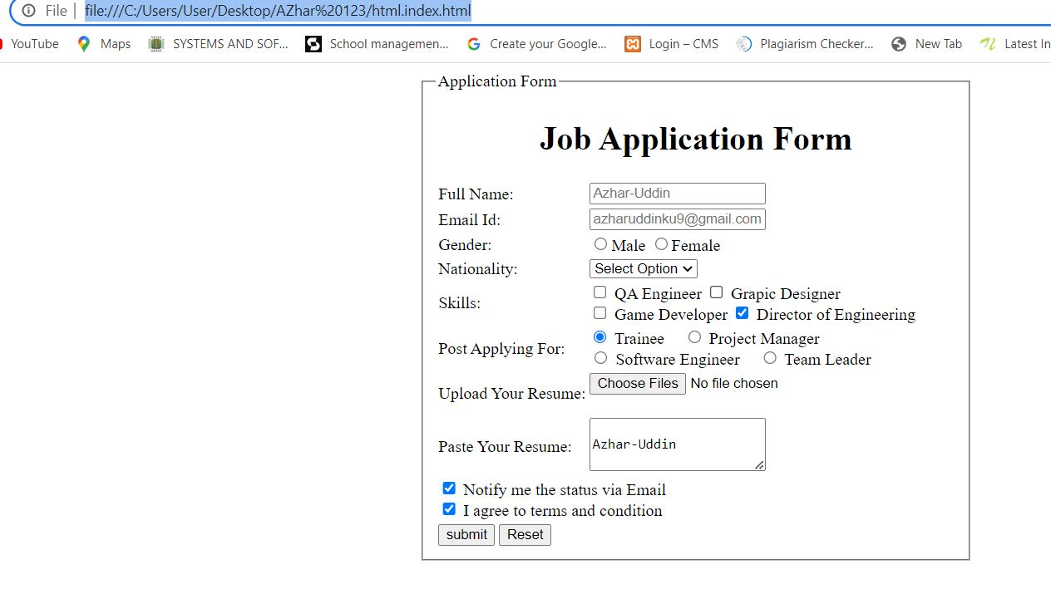

The End

